|  |
| --- |
| City of Glasgow College |
| Screenshots |
| OOP: Centralia College Project |
|  |
| **Niall Ferguson** |
| **4/19/2013** |

|  |
| --- |
|  |

## Main Menu(error reading file)

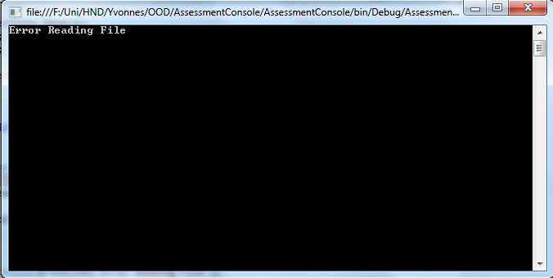

## Main Menu

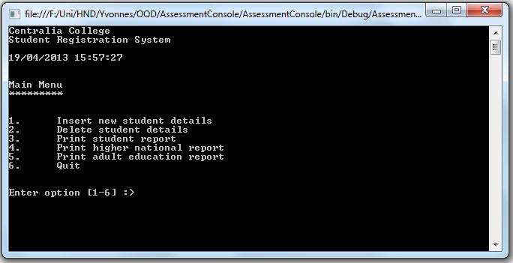

## Adding New Student

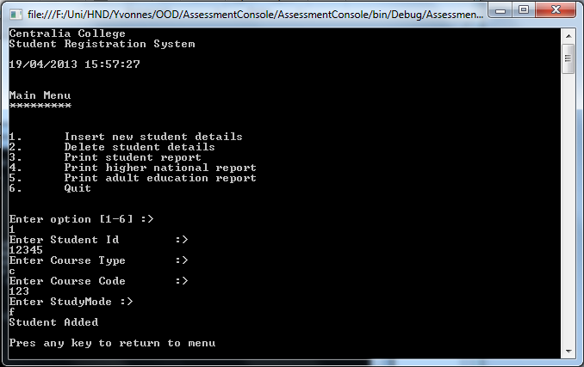

## Adding Student with ID that already exists

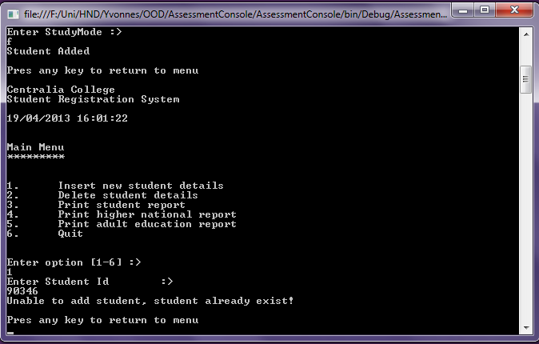

## Deleting Student with ID that does not exists

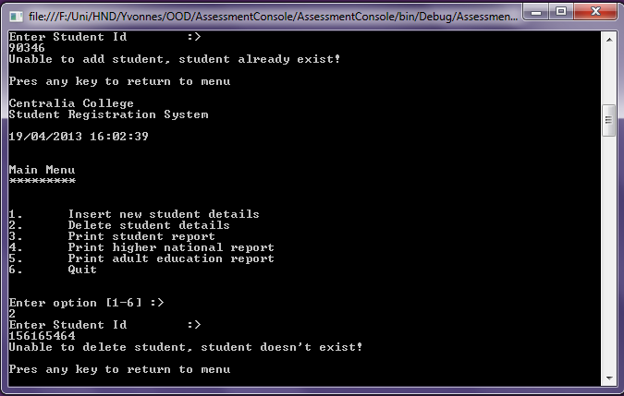

## Deleting Student

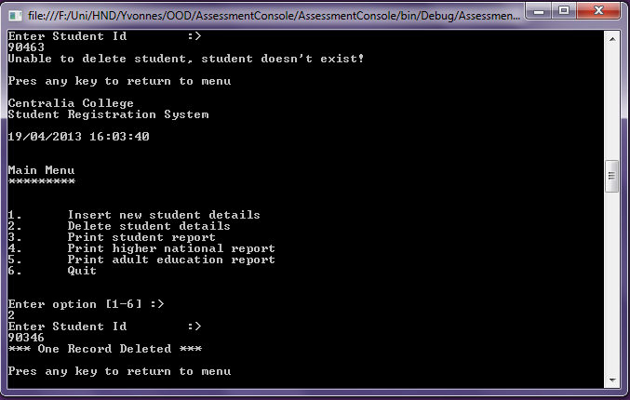

## Printed report of all Students

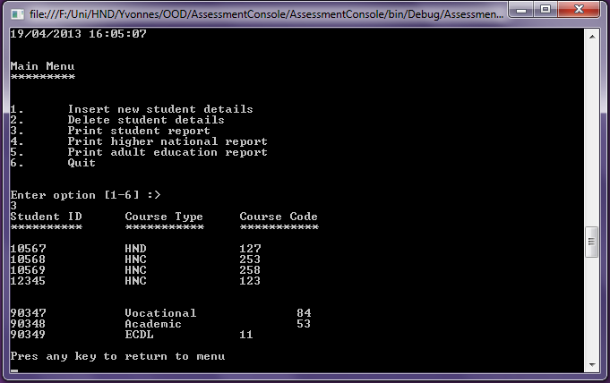

## Report of all Higher National Students

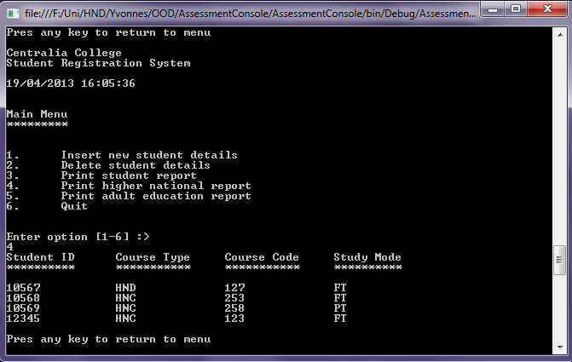

## Report of all Adult Students

